Tessella Project Number: 7567
Tessella plc 26 The Quadrant, Abingdon Science Park, Abingdon, Oxfordshire, OX14 3YS, UK
T: +44 (0)1235 555511 | F: +44 (0)1235 553301 | E: info@tessella.com | www.tessella.com

Client: STFC & ORNL
Mantid
PM report to Project Management Board
13th March 2013



Document Control
This document is under document control. All members of the distribution list will receive updated copies whenever alterations are made. All other copies are uncontrolled.

Contributors
Name | Role | Company
Nicholas Draper | Author | Tessella

Document Approval
Name | Role | Company

Distribution
Name | Role | Company
Project Management Board Members | Recipient | STFC & ORNL
Mantid Project Repository | Filing | STFC & ORNL

Revision History
Author | Issue | Date | Description
Nicholas Draper | V1.R1.M0 | 12-Mar-2013 | 1st version written

References
Document | Ref | Date | Details and Version
Project Specification | [PS] |  | https://github.com/mantidproject/documents/blob/master/Project%20Management/ProjectSpecification.doc?raw=true
Stakeholder Plan | [SP] |  | https://github.com/mantidproject/documents/blob/master/Project%20Management/StakeholderPlan.doc?raw=true
Risk Register | [RR] |  | https://github.com/mantidproject/documents/blob/master/Project%20Management/RiskRegister.xls

Table of Contents
1 Introduction 4
1.1 Purpose of this Document 4
1.2 Scope of this Document 4
1.3 Context of this Issue 4
2 Minutes of the previous meeting 4
3 Project Documentation 4
3.1 Stakeholder Plan: 4
3.2 Risk Register: 4
4 Project Status 4
4.1 Development Progress 4
5 Mantid Governance 5
6 Purpose of the Scientific Steering committee(s) 5
7 Discussion of commonalities between scientific strategies ISIS/SNS 6
8 Future Release Dates 7
9 Appendix A 8
9.1 Project Metrics 8
9.2 Ticket completion rate 9
9.3 Project Uptake 10

Introduction

Purpose of this Document
This report details the current state of the Mantid project and presents the agreed agenda for discussion. The project management board will use the information in this report as a basis for the meeting.

Scope of this Document
The scope of this document is limited to the Mantid project, both for progress up to the meeting of the Project management board, and plans for the future.

Context of this Issue
This is the ninth project management report to the Mantid project management board and will provide input to the meeting.

Minutes of the previous meeting
The minutes of the previous meeting are available here:
https://github.com/mantidproject/documents/blob/master/Project%20Management/PMB/Minutes/PMBMinutes30thNov12.docx?raw=true

Project Documentation
The project documentation is available through the links below. The Risk Register has been reviewed and updated. The other documents have not been changed since the last PMB meeting.

Stakeholder Plan:
https://github.com/mantidproject/documents/blob/master/Project%20Management/StakeholderPlan.doc?raw=true
Updates:
Not updated

Risk Register:
https://github.com/mantidproject/documents/blob/master/Project%20Management/RiskRegister.xls
Updates:
Not updated

Project Status

Development Progress
Since the last PMB meeting in November 2012 we have completed two development iterations and released new versions of Mantid on the following dates:
- Release 2.3.2: 17th December 2012
- Release 2.4: 4th February 2013
Development continues at a good pace: see the project metrics in section 9.2. In particular we have made significant improvements to:
- User interface
  - Simplified Tool bar redesign
  - Tof Converter tool
  - Instrument View improvements
    - New Erase Crystal Peaks tool
    - Operations in the Masking Tab, now do only affect the underlying workspace when requested.
  - You can now see details of grouped detectors in the display detectors table.
- Framework
  - A large collection of file loading improvements
  - Curve fitting and optimisation
    - Stability of back to back exponential curve fitting
    - Option to output separate spectra for each function within a CompositeFunction on Fit
  - Visualization of Structure Factors from Molecular Dynamics Simulations
  - Several improvements to Instrument definition files
- Python
  - Set whole numpy array to workspace spectrum
- Technique Specific improvements
  - Can be seen in the Release Notes

Mantid Governance
The report I distributed previously is available here.
https://github.com/mantidproject/documents/blob/master/Project%20Management/PMB/Report%20on%20Open%20Source%20Governance%20Models.doc?raw=true

Purpose of the Scientific Steering committee(s)
I think we agree on the broad concept, but scientists at the different facilities have had different views. We need to agree on a common understanding.

The following improvements to these meetings have been suggested:
- An agenda for the meeting is sent out at least a week before the meeting in order to give the representatives time to consult their groups.
- Items for discussion to be proposed before the meeting and distributed so everyone can come prepared.
- The meeting should be minuted.
- There should be a 'local' chairman for each site and they should take turns to chair the meetings (the frequency of the switching should be discussed).

Other aspects may also be discussed:
- Meeting frequency.
- Is an overview of the release required at each meeting
- Should the Steering Chairman attend the PMB

Discussion of commonalities between scientific strategies ISIS/SNS
This is a discussion to identify areas of common benefit / development, based on the presentation at the last meeting.

Future Release Dates
The planned release dates for the rest of this year would be:
- 3rd May 2013
- 2nd August 2013
- 1st November 2013
This does not include patch releases.

Appendix A

Project Metrics
SubProject | Files | Statements | %comments
Mantid Framework | 3,454 (3,108) | 367,568 (332,874) | 20.1 (19.9)
MantidPlot | 766 (724) | 115,710 (112,862) | 15.8 (15.6)
VATES | 239 (278) | 10,294 (11,782) | 22.5 (21.3)
Total | 4,459 (4,110) | 493,572 (457,518)
The metrics are defined as follows:
Metric | Description
Files | The number of .h, .cpp and *.py files (not including third party libraries) included in the analysis.
Statements | The number of valid C++ statements, loops, conditional statements and pre processor directives are included.
% Comments | This is the percentage of the overall number of lines which are comment lines. I have not directly reported the number of lines in the file, but a good rule of thumb is that it is roughly twice the number of statements.
The Mantid Framework code has significantly grown since the last PMB (the previous values are in brackets), as would be expected with the addition of the new functionality described earlier.

Ticket completion rate
Development on Mantid is performed in three month iterations, each of which ends with an official release of the software. Longer pieces of work sometimes have to span a development iteration in which case that piece of work appears as completed only in the iterations when it becomes available to the users.
The patch releases (2.x.x) are very much smaller and are used to solve issues that become apparent after the main release or release urgent improvements that have recently been added.

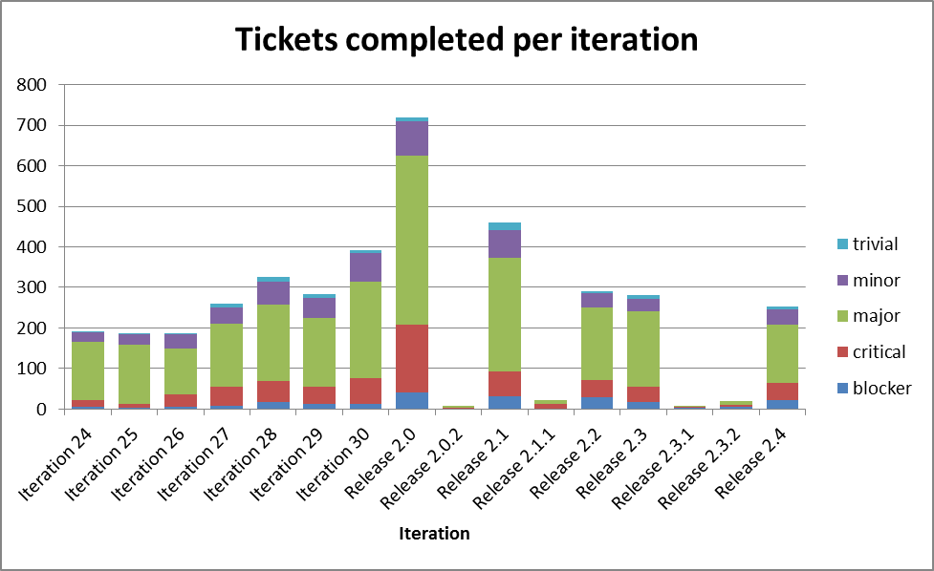

Project Uptake

Mailing List Subscriptions
Our software download site no longer requires people to register to a mailing list in order to download the installer packages. A simple analysis of the email domains shows that while the majority of the users are from ISIS, followed by ORNL and we have had some interest from other institutions and universities.
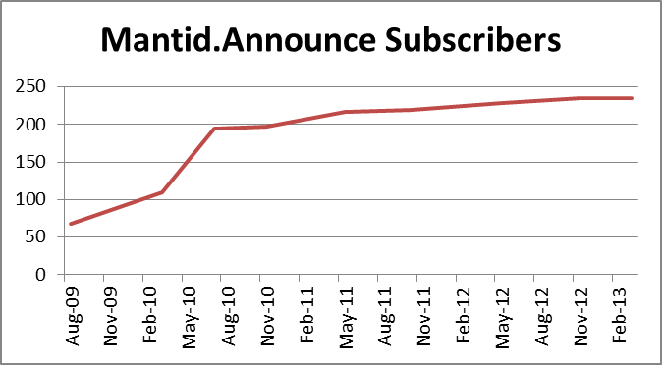
Summary
Date | Users
Aug-09 | 68
Mar-10 | 109
Jul-10 | 195
Nov-10 | 197
May-11 | 217
Oct-11 | 219
May-12 | 228
Nov-12 | 235
Mar-13 | 235

Current domain breakdown (2+)
Domain | 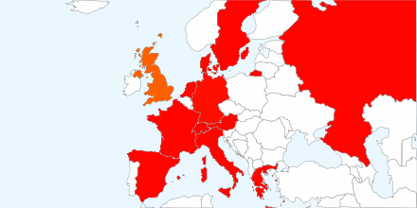  count
stfc.ac.uk | 70
ornl.gov | 28
gmail.com | 22
helmholtz-berlin.de | 9
swansea.ac.uk | 2
sheffield.ac.uk | 2
imperial.ac.uk | 2
caltech.edu | 2
esss.se | 2
owlpic.com | 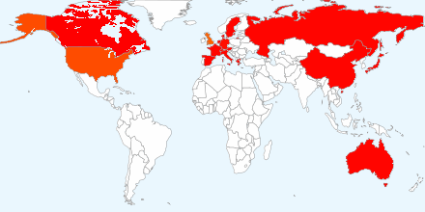  2
tudelft.nl | 2
ill.fr | 2
isc.cnr.it | 2
physics.ox.ac.uk | 2
anl.gov | 2
bath.ac.uk | 2
psi.ch | 2
uwstout.edu | 2
ansto.gov.au | 2
clemson.edu | 2
hmi.de | 2
j-parc.jp | 2
ihep.ac.cn | 2
lanl.gov | 2

Software Downloads
Since December 2010 when we removed the requirement to subscribe to the mailing list, we began to track downloads. We record the ip-address along with the file downloaded, due to the nature of facility users sharing ip-addresses it is not possible to only report on unique ip-addresses, but the total count of downloads is interesting although too much should not be read from it. I should also stress that this does not currently include Unix RPM downloads via the ISIS or SNS Red Hat repositories.

